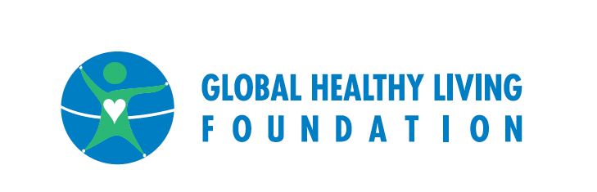

MEDIA ALERT

CONGRESSIONAL BRIEFING ADDRESSES IMPLEMENTATION OF BIOLOGICS PRICE COMPETITION AND INNOVATIONS ACT

Global Healthy Living Foundation Co-Hosts Event Featuring Patient, Industry, and Advocacy Stakeholders to Discuss Implications for Arthritis and Chronic Disease Patients

(Upper Nyack, NY) The Global Healthy Living Foundation, working with the Coalition of State Rheumatology Organizations (CRSO) and the Arthritis Foundation, in cooperation with the Congressional Arthritis Caucus, will co-host a congressional briefing to address the forthcoming availability of biosimilars in light of the U.S. Food and Drug Administration (FDA) not providing final guidance on the approval of biosimilars and interchangeable biological products when it comes to naming, substitution, interchangeability and labeling.

WHAT: “Biosimilars for Arthritis Patients: Challenges and Opportunities”

WHEN: Monday, July 13 from 12-1:00pm EDT

WHERE: B340 Rayburn

WHO: Panelists will address the implementation of the Biologics Price Competition and Innovation Act (BPCIA), which was passed in 2010 as part of the Affordable Care Act. Scheduled to speak and available for interview in advance of the briefing are:
- Dr. Harry Gewanter, Pediatric Rheumatologist, Pediatric & Adolescent HealthPartners; Clinical Associate Professor of Pediatrics, Virginia Commonwealth University School of Medicine; volunteer, Arthritis Foundation
- Kim Greco, Director, Global Regulatory and R&D Policy, Amgen
- Katherine Macfarlane, Patient Advocate, Global Healthy Living Foundation
- Jim McKay, PhD, Director, Clinical Development and Medical Affairs Sandoz Biopharmaceuticals (a Novartis Company)
- Dr. Gregory Schimizzi, Cofounder, Carolina Arthritis; Treasurer, Coalition of State Rheumatology Organizations

CONTACT: Jessica Daitch, Global Healthy Living Foundation, 917-816-6712, jessicadaitch@hotmail.com

About the Global Healthy Living Foundation:
The Global Healthy Living Foundation is a 501(c)(3) non-profit organization whose mission is to improve the quality of life for people living with chronic illnesses by advocating for improved access to care at the community, state, and federal levels, and amplifying education and awareness efforts within its social media framework. The Global Healthy Living Foundation is the parent organization of CreakyJoints, the online, non-profit, arthritis patient support community with more than 80,000 members and their families in all 50 states, Western Europe, South America and Australia, and the recently launched Arthritis Power, the first ever patient-led, patient-generated, patient-centered research registry for arthritis.

